Gōngkè-2: Míngzi:_____________________

- Match the Pinyin words below with the right characters or pictures.

- kuàizi | 好
- hē
- chá | 喝
- fànguǎn | 菜
- chī | 茶
- hǎo | 吃
- cài | 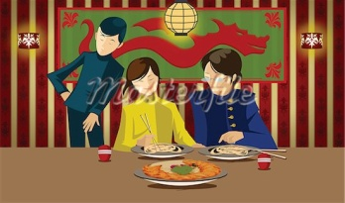
- Circle the Chinese character (or characters) that best describes the pictures given:

Example:
Wǒ cháng ( 吃，喝， 茶，菜，好) 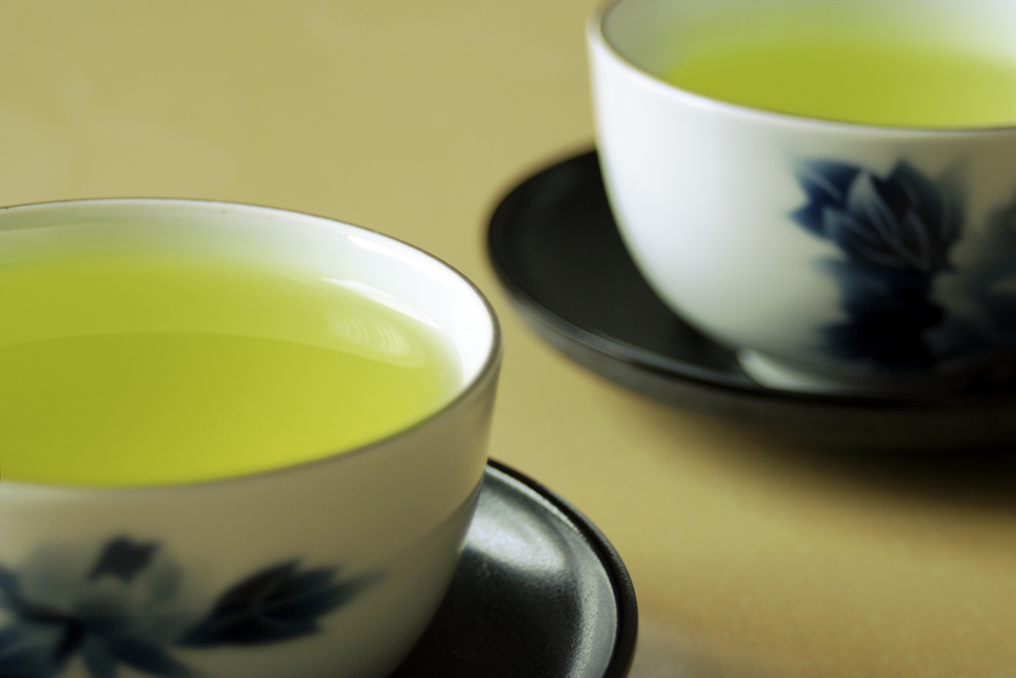
- Tā měitiān ( 吃，喝， 茶，菜，好) 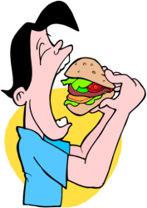 měiguó fàn.
- Lǎoshī cháng ( 吃，喝, 茶，菜，好) 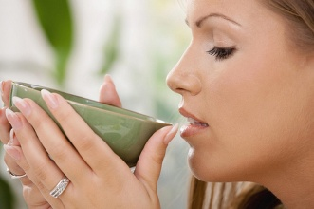 .

- tā xǐhuān hóng（ 吃 ，喝，茶，菜，好）ma?
- Nǐ chángbùcháng（ 吃 ，喝，茶，菜）zhōngguó （ 吃 ，喝，茶，菜）?
- Nǐmen ài（ 吃 ，喝，茶，菜，好）shénme （ 吃 ，喝，茶，菜）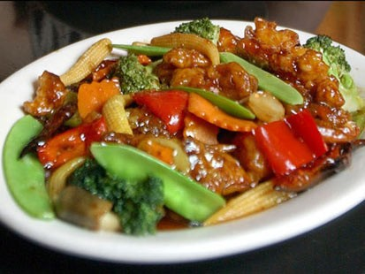?

- Circle the answers that best complete the paragraph.
Zuótiān wǒ gēn wǒ māma yìqǐ (吃，渴，喝，茶，菜) wǔfàn.
Wǒ māma xǐhuān (吃，喝，茶，菜) rìběn(吃，渴，喝，茶，菜).
Zhōngguó菜hěn （好吃，好喝，好茶）
Zhōngguó 茶 hěn（好吃，好喝，好菜）
Wǒmen qù rìběn fànguǎn (吃，渴，喝，茶，菜) fàn.
Wǒmen (吃，渴，喝，茶，菜) hóng (吃，渴，喝，茶，菜) , (吃，渴，喝，茶，菜) mǐfàn.
Rìběn (吃，渴，喝，茶，菜) hěn (hǎo吃, hǎo kàn, hǎowán, hǎo喝).

